# Thermal summation model and instar determination of all developmental stages of necrophagous beetle, Sciodrepoides watsoni (Spence) (Coleoptera: Leiodidae: Cholevinae)

Pavel Jakubec

Department of Ecology, Faculty of Environmental Sciences, Czech University of Life Sciences Prague, Kamýcká 129, CZ-165 21 Prague 6 – Suchdol, Czech Republic;

e-mail: jakubecp@fzp.czu.cz

Abstract

Necrophagous beetles are underrepresented in forensic entomology studies despite their undeniable utility for the field. In our article we would like to address this problem and provide information regarding developmental biology and instar determination of *Sciodrepoides watsoni* (Spence, 1813), which is very common species occurring across the Holarctic region. Beetles were kept in climatic chambers at constant temperature (12, 15, 18, 21 and 28°C) and their development was observed and documented regularly. Parameters of thermal summation models and their standard errors were calculated for each developmental stage. These models could be used for an estimation of post mortem interval in legal investigation after validation on local populations of *S. watsoni*. We introduce a new methodology for future studies of size based characters, which is addressing instar identification bias. This methodology was used for estimation of statistical characteristics (mean, standard error and standard deviation) of *S. watsoni's* head width, which was identified as a good additional character for larval instar determination . This charactercould be used along with other morphological features to improve instar determination accuracy.

Introduction

Forensic entomology is a rapidly developing new field of science (Midgley *et al.*, 2010). New methods and models for estimation of minimum post mortem interval (PMImin) are developing at a very rapid pace (e.g., pre-appearance interval, gene expression during larval development, quantile mixed effects models, generalized additive modeling or generalized additive mixed modeling) (Matuszewski, 2011; Tarone & Foran, 2011; Baqué *et al.*, 2015a, 2015b), but even the well-established models lack actual data for their further use and application. A good example is the commonly used thermal summation model (Richards & Villet, 2008). This model, which is based on the assumption that development of immature stages is linear, has been known for several decades (Higley *et al.*, 1986), but it is still not established for the majority of forensically important species of invertebrates, which would be a great contribution to legal investigations.

Currently these models are known for a number of fly species (Diptera) (Nabity *et al.*, 2006; Villet *et al.*, 2006; Richards *et al.*, 2009; Voss *et al.*, 2010a, 2010b, 2014; Tarone *et al.*, 2011; Nassu *et al.*, 2014; Zuha & Omar, 2014), but because the utility of beetles in forensic entomology was overlooked for a long time (Midgley *et al.*, 2010), there are only a three species of beetles with known thermal summation models (Midgley & Villet, 2009a; Velásquez & Viloria, 2009; Ridgeway *et al.*, 2014).

However, using beetles for PMImin estimation has several benefits compared to flies. Beetles tend to have longer development therefore they can be found on and around the carrion for a longer period of time (Villet, 2011). They also do not form a maggot ball like flies and they can be reared individually so they are easier to handle in laboratory conditions (Midgley *et al.*, 2010). However, we think that the biggest advantage is the possibility of cross validating PMImin estimates between species and groups, such as flies and mites. This is important mainly in cases when one of these groups or species could have been affected by external factors (restricted access to body, temperature too high or low, etc.) and give biased estimate (Šuláková 2014, pers. comm.).

As mentioned above, statistically robust thermal summation models are only known for three species of necrophagous beetles, all of them belonging to the family Silphidae. These are *Thanatophilus micans* (Fabricius, 1794) (Ridgeway *et al.*, 2014), *T. mutilatus* (Castelnau, 1840) (Ridgeway *et al.*, 2014) and *Oxelytrum discicolle* (Brullé, 1840) (Velásquez & Viloria, 2009). *T. micans* occurs mainly in Africa and extends to Yemen on the Arabian Peninsula (Schawaller, 1981; Růžička & Schneider, 2004), *T. mutilatus* has a geographical distribution restricted to South Africa region (Schawaller, 1981, 1987) and *O. discicolle* inhabits Central and South America (Peck & Anderson, 1985). This leaves North America, Europe and most of Asia without a single beetle species with a known thermal summation model.

Models alone are not sufficient to make a species available for use in legal investigation. There are other criteria to be fulfilled. Any forensic entomologist has to be able to identify those species in every stage of development and discriminate between larval instars. Without reliable instar determination it is not possible to expect reliable PMImin estimates. But this is sometimes complicated, because beetle larvae often lack morphological characters specific to particular instars, which would allow such identification (Velásquez & Viloria, 2009). Therefore size based models were developed instead for number of them (Midgley & Villet, 2009b; Velásquez & Viloria, 2010; Fratczak & Matuszewski, 2014). These models should cover large morphological variability of the size based characters, which are commonly reported in morphological descriptions, but based on few specimens. Midgley & Villet (2009b), Velásquez & Viloria (2010) and Fratczak & Matuszewski (2014)identified body length of larvae as inaccurete and unrealiable character for instar determination and they proposed number of other size based characters to use instead. Despite some problems with methodology of those papers these characters are available only for two European species, namely *Necrodes* *littoralis* (Linnaeus, 1758) (Silphidae) and *Creophilus* *maxillosus* (Linnaeus, 1758) (Staphylinidae) (Fratczak & Matuszewski, 2014).

*Sciodrepoides* *watsoni* (Spence, 1813) is one of the most widespread and abundant species of necrophagous beetles in the Holarctic region (Peck & Cook, 2002; Perreau, 2004). Robust occurrence data are available especially for Europe (see Fig. 1). This saprophagous beetle belongs to subfamily Cholevinae (Leiodidae) and is rather inconspicuous, because the whole body is brown and about 3 millimeters long (Szymczakowski, 1961; Perreau, 2004) (see Fig. 2). Adults can be fairly easily distinguished from the other European species of genus *Sciodrepoides* by the shape of the antennal segments (Szymczakowski, 1961). The main peak of activity is during the warmer parts of the year (late spring and summer) (Růžička, 1994). All stages can be found on decaying corpses of vertebrates in various types of habitats where they feed and develop (Růžička, 1994; Peck & Cook, 2002; Topp, 2003).

Egg, all larval instars and pupae of this beetle were properly described recently by (Kilian & Mądra, 2015) and also DNA barcode for possible validation is available (Schilthuizen *et al.*, 2011). Therefore identification of this species in every stage of development is not an issue.

Instar determination of *S. watsoni* larvae is also possible thanks to Kilian & Mądra (2015), but its natural variability was not covered in the case of some size based characters.

We would like to improve the utility of *S. watsoni* for PMImin estimation by calculating the parameters of thermal summation models for each stage (egg, three larval instars and pupae) and developing a new additional character for instar determination, which would cover natural variability and could be easily observed, measured and evaluated. We also developed a new method for establishing a size based characters for the instar determination, which is described in the methodology section.

Material and Methods

A laboratory colony was started with adults of *S. watsoni*, which were collected in spring of 2012 and/or 2013 from five localities in the Czech Republic (Prague – Suchdol (15 May – 12 April 2012, 15 May – 12 April 2013), Běstvina (7 – 11 April 2012, 6 – 10 April 2013), Domažlice (28 May – 12 April 2013) and Klatovy (14 – 28 May 2013)).

Beetles were collected using 10 baited pitfall traps, placed at each locality. The traps composed of 1,080 ml plastic buckets (opening of 103 mm and 117 mm deep). These buckets were embedded in substrate up to the rim to eliminate any obstructions which could deter beetles from entering. As protection against rain we put metal roofs (150x150 mm) over the traps. The roof was supported by four 100 mm nails, one in each corner, and placed approximately two centimeters above the surface. The bait, ripened cheese (Romadur) and fish meat (*Scomber* *scombrus* Linnaeus, 1758), was placed directly inside the bucket on a shallow layer of moist soil. This created good conditions for survival of the trapped beetles between servicing, which was usually done once a week.

After transport to our laboratory we confirmed identification and sexed the beetles under binocular microscope (Olympus SZX7). Most of the beetles were than randomly assigned to form breeding groups of at least four individuals (2 males and 2 females). Specimens from the same locality were kept together regardless of capture date to eliminate cross-breeding of different populations. These groups were formed to produce new progeny, which we than observed throughout of their development (breeding experiment).

These groups were kept in Petri dishes with the layer of soil and small piece (approx. 5x5 mm) of fish meat (*Scomber* *scombrus*) as a food source. The content of the dish was lightly sprayed with tap water every day and food was provided *ad libitum* and changed if we spotted any sign of fungal growth.

The dishes were randomly placed in one of six climatic chambers (custom made by CIRIS s.r.o.). The chambers were set up at constant temperature (12, 15, 18, 21, 25 or 28°C) and 16 hours of light and 8 hours of dark photoperiod regime, maintained by fluorescent light (Osram L 8W/640). We tried to have a similar number of breeding groups from the same locality in each chamber. We accomplished that in case of beetles from Praha and Běstvina, but it was not possible for beetles from Domažlice and Klatovy, because of a low number of adults obtained. Therefore we kept them together in one treatment (18°C).

We also started an observation study of their natural behavior. The study was conducted in a small plastic box (15x6x2 centimeters) with 12 adult individuals (7 females and 5 males) from Prague population. In this colony we did not separate larvae from adults or each other, but we allowed them to interact freely and without our intervention (measuring, photographing or other manipulations). The box itself was placed in 18°C treatment and its inhabitants were attended in the same way as the specimens in the breeding experiment (regular water spray and meat replaced if we saw a sign of fungal growth).

In the breeding experiment we slightly changed our method of handling eggs and first instar between the years to improve accuracy of our observations. During the first year of experiment (2012) we searched the dishes for eggs and then we transferred them individually to separate dish. But due to the fact that eggs of *S. watsoni* are very small and adults tended to hide them in the substrate, we struggled to find them right after laying. Due to that our estimation of egg and L1 development for the first year were inconsistent, we did not use them for models.

To minimize this error we chose different approach for the second year (2013). We instead transferred the whole breeding group to a new Petri dish every day. The old dishes were marked and kept in the same climatic chamber as the parents. We checked them every day for emergence of the first instar larvae that were further separated into their own dishes, so the individual development could be observed. The time when the eggs were laid, was estimated as a half-time between the transfers of the breeding group.

Every larva from the second year (2013) breeding experiment was photographed every day, starting with their occurrence as the first instar larvae and we continued until pupation. In this way we continuously documented morphological changes during their development. The protocol for documentation was following. We took out the Petri dish from the climatic chamber and placed it under the stereoscopic microscope and located the larva. They tended to stay around the food source, but not always. The larva was transferred with fine brush on white sheet of paper and photographed. Once we obtained usable picture we returned the larva back into Petri dish and back to corresponding climatic chamber. The whole process of finding the larva and taking a picture did not usually take more than 1 minute in total. Key developmental stages of each larva with the accurate date and time could be distinguished based on those photographs simply by keeping track of the change in the width of their head capsule, because its size expand after each molt. This was very useful for data collection, because we did not have to search for exuvia to be sure that our larva is in the next instar.

It happened sometimes that we were unable to find some larva in its Petri dish. In that case we treated the dish as possibly full and put it back into its treatment and tried another day. If the larva changed instar before we found it, we counted length of both instars as NAs and we tried to keep track of this larvain the next stages.

We used obtained photographs for the instar determination. Because, the dorsal side of all the larvae was photographed daily, we had plenty of characters to choose from. However, the thorax and abdomen of the *S. watsoni* larvae are not strongly sclerotized (see Fig. 3), so we omitted these parts, and also the body length, as good characters for instar determination, because they would vary between measurements too much. Measuring of some smaller parts such as urogomphi or antennae was impractical, because it is very challenging to measure them accurately on a living and moving animal. We could not use chilling or CO2 immobilization, because it would stress our specimens even more and it could potentially affect the length of the development.

The most stable and reliable feature for the instar determination of *S. watsoni* larvae appears to be the head capsule. This part of the body is strongly sclerotized, therefore it is not affected by water or food content, but it changes its size after each molt so it is tightly linked with individual growth. Also the head does not change its size in different fixation media or even after desiccated, thus the instar can be identified even for very poorly handled and long dead specimens. Ultimately, we chose the head width over its length for a practical reason. Head width of living larvae do not change on the pictures captured from above, but length varies a lot.

For estimating the mean and standard deviation of the head capsule width (measured in the widest point) we used all photographs where the head was clearly visible and was sharp enough to make a precise measurement. All measurements were done with graphical program EidosMicro calibrated by precise ruler.

Parameters of thermal summation model (lower developmental threshold (t) and sum of effective temperatures (k)) were estimated for each developmental stage using the major axis regression method ((DT)= k +tD) where D is duration of development, T is environmental temperature (°C). This formula was developed by (Ikemoto & Takai, 2000) and is commonly used for estimation of thermal summation parameters and their standard errors in forensic entomology (e.g., (Midgley & Villet, 2009a; Ridgeway *et al.*, 2014)). (Ikemoto & Takai, 2000) method is based on standard linearized formula (1/D = — (t/k) + (1/k)T), but it weights out the data points in lower and upper part of the temperature range to obtain more reliable estimates of the parameters.

Normality of all the data was confirmed by evaluation of the qqplots and histograms. The significance level was set at 5%. Data management and all analysis were carried out using R statistical program (R Core Team, 2015). Graphical outputs were handled by ggplot2 and ggmap R packages (Wickham, 2009; Kahle & Wickham, 2013).

Results

In total, we were able to catch 81 adult specimens of S*. watsoni* and they produced 399 first instar larvae (Prague – 174, Běstvina - 178, Klatovy - 19, Domažlice - 28) for the breeding experiment. Because we obtained only twelve adults from Klatovy and six from Domažlice, it was impossible to split them between all our treatments. Therefore we decided to keep them all at 18°C.

In the breeding experiment we observed, directly or indirectly, and recorded duration of the development of all *S. watsoni* stages, namely egg, three larval instars (L1, L2 and L3) and pupae. These observations were made on 399 specimens in total starting with the first instar larvae.

Higher temperatures (25 and 28°C) were probably limiting to breeding activity of our beetles in the experiment. Ultimately we did not obtain any larvae from the 28°C treatment. Mortality in the other treatments was also quite high especially for the third instar and pupae (see Fig. 4) and only 23 individuals developed until adulthood. Low temperature also prevented breeding and we did not observe any larvae in 12°C treatment.

The development times differed between stages (Fig. 5) and the mean development time decreased with increasing temperature (Fig. 6), except for L2 and L3 instars in 25°C treatment. The sum of effective temperatures (k) and lower developmental threshold (t) values were calculated for all developmental stages of *S. watsoni* with their expected errors (see Table 1 and Fig. 7).

Mortality of the specimens in the observation study could not be measured, but the colony itself prospered very well and number of adults increased steadily, which is in contrast with what we observed in the breeding experiment. The observed females tended to hide their eggs in small holes or crevices in the substrate. Newly hatched larvae could be found mostly around the food source. The third instar larvae after few days of feeding dug underground and created small chamber where they pupate. No cannibalism or hostility of any kind between individuals was recorded.

For the instar determination measurements we made 2,104 photographs, but only 1,731 were good enough to allow precise measurements of the head width. Those pictures covered all three larval instars (L1 = 591, L2 = 500 and L3 = 640 pictures). The bias in number of pictures between different stages was caused by difference in the duration of development of these instars (lower stages of development are shorter in duration) and it was also much more challenging to take a usable picture of the first or second instar larvae.

The mean width of the head appears to be a good additional character for the instar determination (see Table 2 and Fig. 8). Standard deviations are well separated and there is only a small overlap between 75th and 25th quintiles across all instars. We recorded some extreme values on the both sides of the spectrum, but these were very rare. If this character is used along with morphological characters like chaetotaxy and brown spot on the head mentioned by Kilian & Mądra (2015) it could potentionaly improve the accuracy and precision of larval instar determination of *S. watsoni*.

Discussion

We did not obtain any larvae from the 28 and 12 °C treatment probably because adults did not oviposit in this temperature or egg mortality was too high. The second claim is little bit more likely from our point of view, because we did not find any eggs. But as we mentioned in the methodology section, eggs of *S. watsoni* are tiny and we could simply overlook them during our controls in the Petri dish's substrate even under the binocular microscope.

Mortality of our specimens in the breeding experiment was very high over the all treatments especially in the third instar). High mortality in this stage is not uncommon, but in this case it was in a sharp contrast with what we saw in the observation study. The whole colony in the observation study prospered and even increased in the number of adults over time. Only difference between these two was that we did not separate individuals and we also did not have to handle the larvae for photo documentation.

Despite the increased mortality of some stages in breeding experiment the total length of development (from egg until adulthood) did not differ significantly from values in our observation study (ca. 28 days at 18°C) and also those reported by Kilian & Mądra (2015) (ca. 20 days at 20°C). Therefore we have no reason to think that larvae in breeding experiment prolonged their development due to unfavorable conditions. Larvae also did not increase or decrease number of their instars and they had to undergo three larval instars before maturation, which was also reported by Kilian & Mądra (2015).

We did not observe any hostility between specimens in the observation study or signs of cannibalism between individuals as reported by (Kilian & Mądra, 2015), but it is possible that we missed it, because the estimated number of larvae and adults in the box was close to one hundred.

We think that photographing process was not so intrusive to be responsible for such high mortality rates thus it is more likely that separation from other larvae and adults was the reason for that. Peck (1975) mentioned that cave adapted beetle *Ptomaphagus hirtus* (Tellkampf, 1844) (Leiodidae: Cholevinae: Ptomaphagini) needed soil from its cave of origin to successfully complete the development. Soil bacteria probably play some part in this process, because specimens did not develop on autoclaved soil. It is possible that adults feeding along with larvae could have provided such bacteria in our case. Another explanation could be that feeding of multiple individuals is much more effective or improves the quality of the food source. As a support for this claim we observed a very rapid growth of some fungi in Petri dishes with a single larva, but almost none in the observational study containers where a large number of individuals were feeding.

We had to change our methodology of egg extraction for the second year due to the fact that eggs could be easily overlooked in the substrate and beetles refused to lay their eggs in offered damp cotton wool balls or small pieces of paper. To prevent bias in recorded time we introduced dish rotation methodology and adults stayed in the same dish only one day and then were moved to another. Those used dishes were then regularly searched for emerging larvae. The main issue with this approach (dish rotation) is that we could not measure egg mortality, because we could not count the original number of eggs.

The mean development time decreased with increasing temperature (Fig. 6), except for L2 and L3 instars in the 25°C treatment. This might indicate that between 21°C and 25°C should be an optimal temperature (temperature with highest developmental rate where the specimen is still able to reach maturity) for the development of these two stages. Optimal temperatures for lower stages could be probably even higher, but the specimens from these were not able to reach the maturity. This agrees with findings of Engler (1981), who reported *S. watsoni* as warm season species in contrast to some species of *Choleva* and *Catops* that prefers to breed during the winter season and their optimal temperatures for development were below 16°C (e.g., *Catops* *nigricans*, C*holeva* *agilis* and *Ch*. *elongata*). It also agrees with findings of Ridgeway et al. (2014) who reported that optimal temperature for Afrotropic *Thanatophilus mutilatus* is between 14 - 25 °C.

As you can see in Table 1, we had low number repeats for L3 and pupae. This was caused by high mortality rates of both instars. Measuring development time for pupae was even more challenging and we had difficulties measuring it precisely due to the fact that they did not pupate close to the wall of Petri dish. Therefore we had to search for them. This was sometimes unsuccessful and some specimens surprised us after time when they appeared as adults, because they had been missing and presumed dead.

Our methodology of measuring the size of the instars was based on continual observation of separated individuals from egg until pupation, so we had an information in which stage they were regardless of their size. This approached differs from other studies with similar goals (Velásquez & Viloria, 2010; Fratczak & Matuszewski, 2014), where authors tried to estimate the stage of development based on the size of selected characters without prior knowledge of the true stage of the specimen. This approach is from our point of view a little bit problematic, because those measured characters are correlated, therefore bigger larvae could be misidentified as higher instar than they really are. This bias would probably not affect the obtained mean values, but it would give a distorted picture of variation and ultimately give false confidence in determinations based on them.

As can be seen on Fig. 8 and Table 2, all instars have some overlap in the head widths. This is especially true for the first and second instar. It would not help to measure more characters, because they are correlated, but we offer a different solution. A first instar larva has only primary setae on its body and head is without any colored spots, but after molting to the second instar a secondary set of setae will emerge and brown spot will appear on the head (light brown and not fully defined) (Kilian & Mądra, 2015). Setae are also present without any change on the third instar larvae, but the brown spot is much darker with sharp and well defined edge (Kilian & Mądra, 2015). Thus chaetotaxy and pigmentation of the head can be used for the discrimination of the first and second instar larvae. For additional differential diagnosis of those morphological characters, see (Kilian & Mądra, 2015).We established developmental parameters for *Sciodrepoides* *watsoni* together with the new and reliable character for instar determination. This species is so far the smallest necrophagous beetle with a known thermal summation model. The developmental characteristics provided in this study will help to estimate the PMImin in cases where it was not possible before. The instar determination is the integral part of the PMImin estimation, because without accurate determination of instar we could not reach the right conclusion. We strongly encourage other authors to adopt our methodology for establishing size based instar characteristics, because it provides an accurate picture of its variability.

Acknowledgements

I would like to thank A. Honěk and P. Saska for sharing their insight about beetle development and construction of thermal summation models. I am also grateful to Jan Růžička and Max Barclay who provided many valuable comment and language corrections. This research would not have been possible without the help of my students from the Czech University of Life Sciences Prague: T. Račáková, J. Pšajdl and M. Slachová, who took care of the experiment at times I could not.

References

Baqué, M., Amendt, J., Verhoff, M.A. & Zehner, R. 2015a: Descriptive analyses of differentially expressed genes during larval development of Calliphora vicina (Diptera: Calliphoridae). *International Journal of Legal Medicine*, **129**, 891–902.

Baqué, M., Filmann, N., Verhoff, M.A. & Amendt, J. 2015b: Establishment of developmental charts for the larvae of the blow fly Calliphora vicina using quantile regression. *Forensic Science International*, **248**, 1–9.

Engler, I. 1981: Vergleichende Untersuchungen zur jahreszeitlichen Einpassung von Catopiden (Col.) in ihren Lebensraum. *Zoologische Jahrbücher. Abteilung für Systematik, Geographie und Biologie der Tiere*, **109**, 399–432.

Fratczak, K. & Matuszewski, S. 2014: Instar determination in forensically useful beetles Necrodes littoralis (Silphidae) and Creophilus maxillosus (Staphylinidae). *Forensic Science International*, **241**, 20–26.

GBIF. 2015: Sciodrepoides watsoni [WWW Document]. URL http://www.gbif.org/species/4445042 [accessed on 2015].

Higley, L.G., Pedigo, L.P. & Ostlie, K.R. 1986: Degday: A Program for Calculating Degree-days, and Assumptions Behind the Degree-day Approach. *Environmental Entomology*, **15**, 999–1016.

Ikemoto, T. & Takai, K. 2000: A New Linearized Formula for the Law of Total Effective Temperature and the Evaluation of Line-Fitting Methods with Both Variables Subject to Error. *Environmental Entomology*, **29**, 671–682.

Kahle, D. & Wickham, H. 2013: ggmap : Spatial Visualization with. *The R Journal*, **5**, 144–161.

Kilian, A. & Mądra, A. 2015: Comments on the biology of Sciodrepoides watsoni watsoni (Spence, 1813) with descriptions of larvae and pupa (Coleoptera: Leiodidae: Cholevinae). *Zootaxa*, **3955**, 45–61.

Matuszewski, S. 2011: Estimating the pre-appearance interval from temperature in Necrodes littoralis L. (Coleoptera: Silphidae). *Forensic Science International*, **212**, 180–188.

Midgley, J.M., Richards, C.S. & Villet, M.H. 2010: The Utility of Coleoptera in Forensic Investigations. In *Current Concepts in Forensic Entomology* (ed. by Amendt, J., Goff, M.L., Campobasso, C.P. & Grassberger, M.). Springer Netherlands, Dordrecht, pp. 57–68.

Midgley, J.M. & Villet, M.H. 2009a: Development of Thanatophilus micans (Fabricius 1794) (Coleoptera: Silphidae) at constant temperatures. *International Journal of Legal Medicine*, **123**, 285–292.

Midgley, J.M. & Villet, M.H. 2009b: Effect of the killing method on post-mortem change in length of larvae of Thanatophilus micans (Fabricius 1794) (Coleoptera: Silphidae) stored in 70% ethanol. *International Journal of Legal Medicine*, **123**, 103–8.

Nabity, P.D., Higley, L.G. & Heng-Moss, T.M. 2006: Effects of temperature on development of Phormia regina (Diptera: Calliphoridae) and use of developmental data in determining time intervals in forensic entomology. *Journal of Medical Entomology*, **43**, 1276–86.

Nassu, M.P., Thyssen, P.J. & Linhares, A.X. 2014: Developmental rate of immatures of two fly species of forensic importance: Sarcophaga (Liopygia) ruficornis and Microcerella halli (Diptera: Sarcophagidae). *Parasitology Research*, **113**, 217–22.

Peck, S. 1975: The life cycle of a Kentucky cave beetle, Ptomaphagus hirtus, (Coleoptera; Leiodidae; Catopinae). *International Journal of Speleology*, **7**, 7–17.

Peck, S. & Anderson, R. 1985: Taxonomy, phylogeny and biogeography of the carrion beetles of Latin America (Coleoptera: Silphidae). *Quaestiones Entomologicae*, **21**, 247–317.

Peck, S.B. & Cook, J. 2002: Systematics, distributions, and bionomics of the small carrion beetles (Coleoptera: Leiodidae: Cholevinae: Cholevini) of North America. *The Canadian Entomologist*, **134**, 723–787.

Perreau, M. 2004: Family Leiodidae Fleming, 1821. In *Catalogue of Palaearctic Coleoptera Hydrophiloidea Histeroidea Staphylinoidea* (ed. by Löbl, I. & Smetana, A.). Apollo Books, Steensrup, pp. 133–203.

R Core Team. 2015: R: A Language and Environmnet for Statistical Computing.

Ridgeway, J. a., Midgley, J.M., Collett, I.J. & Villet, M.H. 2014: Advantages of using development models of the carrion beetles Thanatophilus micans (Fabricius) and T. mutilatus (Castelneau) (Coleoptera: Silphidae) for estimating minimum post mortem intervals, verified with case data. *International Journal of Legal Medicine*, **128**, 207–220.

Richards, C.S., Crous, K.L. & Villet, M.H. 2009: Models of development for blowfly sister species Chrysomya chloropyga and Chrysomya putoria. *Medical and Veterinary Entomology*, **23**, 56–61.

Richards, C.S. & Villet, M.H. 2008: Factors affecting accuracy and precision of thermal summation models of insect development used to estimate post-mortem intervals. *International Journal of Legal Medicine*, **122**, 401–408.

Růžička, J. 1994: Seasonal activity and habitat associations of Silphidae and Leiodidae: Cholevinae (Coleoptera) in central Bohemia. *Acta Societatis Zoologicae Bohemoslovicae*.

Růžička, J. & Schneider, J. 2004: Family Silphidae Latreille, 1807. In *Catalogue of Palaearctic Coleoptera, Vol. 2: Hydrophiloidea - Histeroidea - Staphylinoidea* (ed. by Löbl, I. & Smetana, A.). Apollo Books, Steenstrup, pp. 229–237.

Schawaller, W. 1981: Taxonomie und Faunistik der Gattung Thanatophilus (Coleoptera: Silphidae). *Stutgarter Beiträge zur Naturkunde, Serie A (Biologie)*, **351**, 1–21.

Schawaller, W. 1987: Faunistische und systematische Daten zur Silphidae-Fauna Südafrikas (Coleoptera: Silphidae). *Entomofauna*, **8**, 277–285.

Schilthuizen, M., Scholte, C., Wijk, R.E.J. van, Dommershuijzen, J., Horst, D. van der, zu Schlochtern, M.M., *Lievers, R., Groenenberg, D.S.J.* 2011: Using DNA-barcoding to make the necrobiont beetle family Cholevidae accessible for forensic entomology. *Forensic Science International*, **210**, 91–95.

Szymczakowski, W. 1961: *Klucze do oznaczania owadów Polski, Część XIX Chrząszcze - Coleoptera, Zeszyt 13 Catopidae. [Keys to identification of Poland insects, Part XIX Beetles - Coleoptera, Issue 13 Small carrion beetles - Catopidae)].* Państwowe Wydawnictvo Naukowe, Warszawa.

Tarone, A.M. & Foran, D.R. 2011: Gene expression during blow fly development: improving the precision of age estimates in forensic entomology. *Journal of Forensic Sciences*, **56**, S112–22.

Tarone, A.M., Picard, C.J., Spiegelman, C. & Foran, D.R. 2011: Population and Temperature Effects on Lucilia sericata (Diptera: Calliphoridae) Body Size and Minimum Development Time. *Journal of Medical Entomology*, **48**, 1062–1068.

Topp, W. 2003: Phenotypic plasticity and development of cold-season insects (Coleoptera: Leiodidae) and their response to climatic change. *European Journal of Entomology*, **100**, 233–243.

Velásquez, Y. & Viloria, A.L. 2009: Effects of temperature on the development of the Neotropical carrion beetle Oxelytrum discicolle (Brullé, 1840) (Coleoptera: Silphidae). *Forensic Science International*, **185**, 107–109.

Velásquez, Y. & Viloria, A.L. 2010: Instar determination of the neotropical beetle Oxelytrum discicolle (Coleoptera: Silphidae). *Journal of Medical Entomology*, **47**, 723–726.

Villet, M. 2011: African carrion ecosystems and their insect communities in relation to forensic entomology. *Pest Technology,* **5**, 1-15.

Villet, M.H., MacKenzie, B. & Muller, W.J. 2006: Larval development of the carrion-breeding flesh fly, Sarcophaga (Liosarcophaga) tibialis Macquart (Diptera : Sarcophagidae), at constant temperatures. *African Entomology*, **14**, 357–366.

Voss, S.C., Cook, D.F., Hung, W.-F. & Dadour, I.R. 2014: Survival and development of the forensically important blow fly, Calliphora varifrons (Diptera: Calliphoridae) at constant temperatures. *Forensic Science, Medicine, and Pathology*, **10**, 314–21.

Voss, S.C., Spafford, H. & Dadour, I.R. 2010a: Temperature-dependent development of the parasitoid Tachinaephagus zealandicus on five forensically important carrion fly species. *Medical and Veterinary Entomology*, **24**, 189–98.

Voss, S.C., Spafford, H. & Dadour, I.R. 2010b: Temperature-dependant development of Nasonia vitripennis on five forensically important carrion fly species. *Entomologia Experimentalis et Applicata*, **135**, 37–47.

Wickham, H. 2009: ggplot2: elegant graphics for data analysis.

Zuha, R.M. & Omar, B. 2014: Developmental rate, size, and sexual dimorphism of Megaselia scalaris (Loew) (Diptera: Phoridae): its possible implications in forensic entomology. *Parasitology Research*, **113**, 2285–94.

Table 1: Summary of development constants for S. watsoni for five developmental stages. Sum of effective temperatures (k) and lower developmental threshold (t) shown as means with the standard errors (coefficient of determination (R2) and degrees of freedom (Df) and p values are provided).

|  |  |  |  |  |  |  |
| --- | --- | --- | --- | --- | --- | --- |
| **Stage** | **Temperature range** | **R2** | **Df** | ***p* value** | **k** | **t** |
| **Egg** | 15-25 | 0.8134 | 220 | 2.20E-16 | 929.354 ±49.111 | 11.400 ±0.368 |
| **L1** | 15-25 | 0.9375 | 171 | 2.20E-16 | 233.683 ±27.031 | 15.437 ±0.305 |
| **L2** | 15-25 | 0.8768 | 206 | 2.20E-16 | 243.945 ±45.301 | 15.689 ±0.410 |
| **L3** | 15-25 | 0.8199 | 27 | 1.49E-11 | 2602.996 ±297.464 | 9.375 ±0.846 |
| **Pupae** | 15-21 | 0.8563 | 10 | 1.61E-05 | 1207.431 ±489.288 | 12.535 ±1.624 |

Table 2: The head widths (in millimeters) of all three larval instars of *S. watsoni*.

|  |  |  |  |  |
| --- | --- | --- | --- | --- |
| **Instar** | **max.** | **min.** | **mean** | **stand. dev.** |
| **L1** | 0.392 | 0.270 | 0.329 | 0.017 |
| **L2** | 0.479 | 0.350 | 0.421 | 0.021 |
| **L3** | 0.582 | 0.451 | 0.522 | 0.021 |

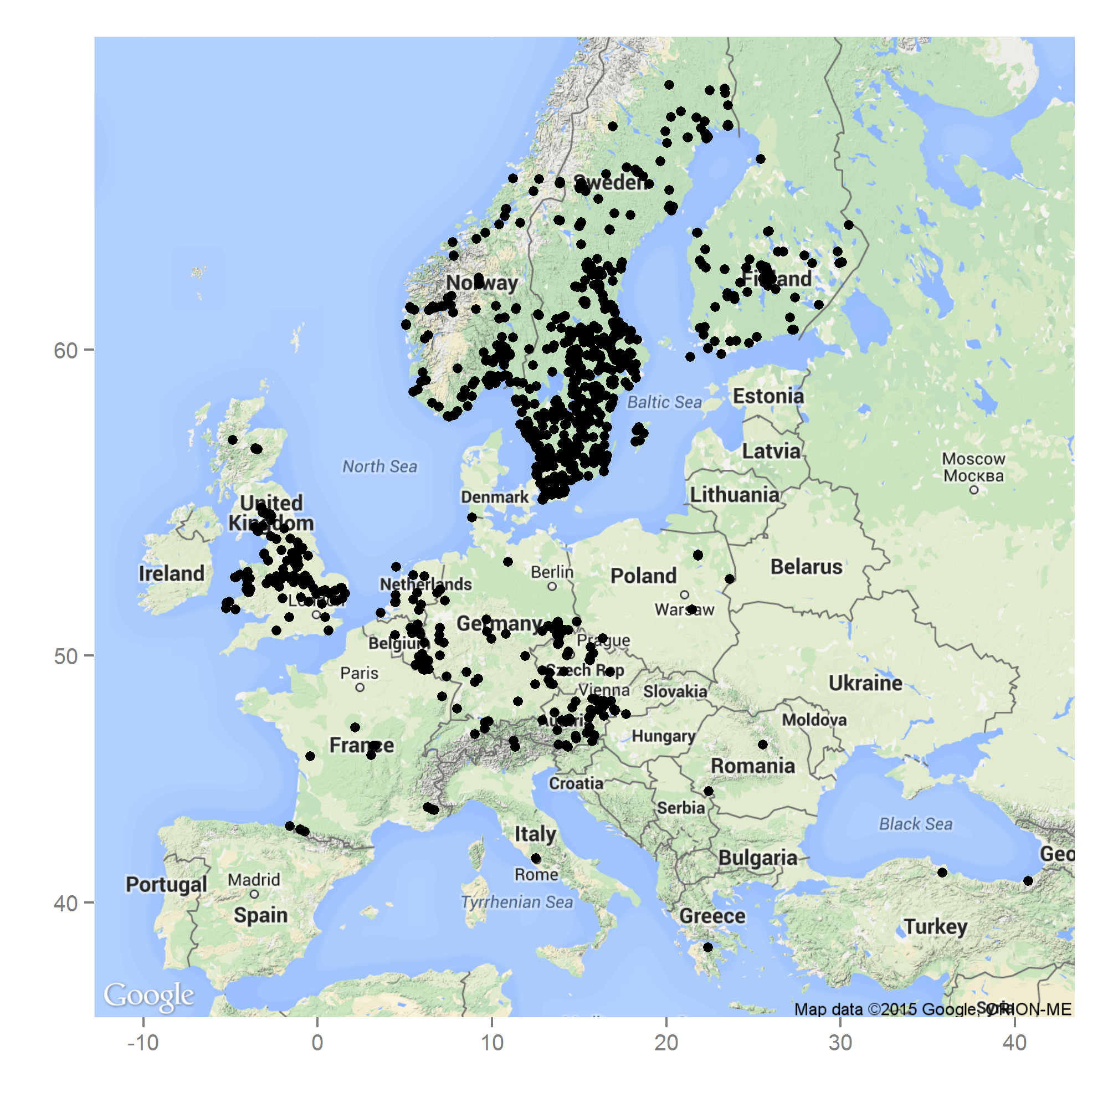

Fig. 1: Occurrence of *S. watsoni* in Europe based on our own observations and records from the GBIF database (GBIF, 2015). Underlying map generated by package ggmap (Kahle & Wickham, 2013).Map data ©2015 Google.

Fig. 2: Habitus of the *S. watsoni* male from dorsal view.

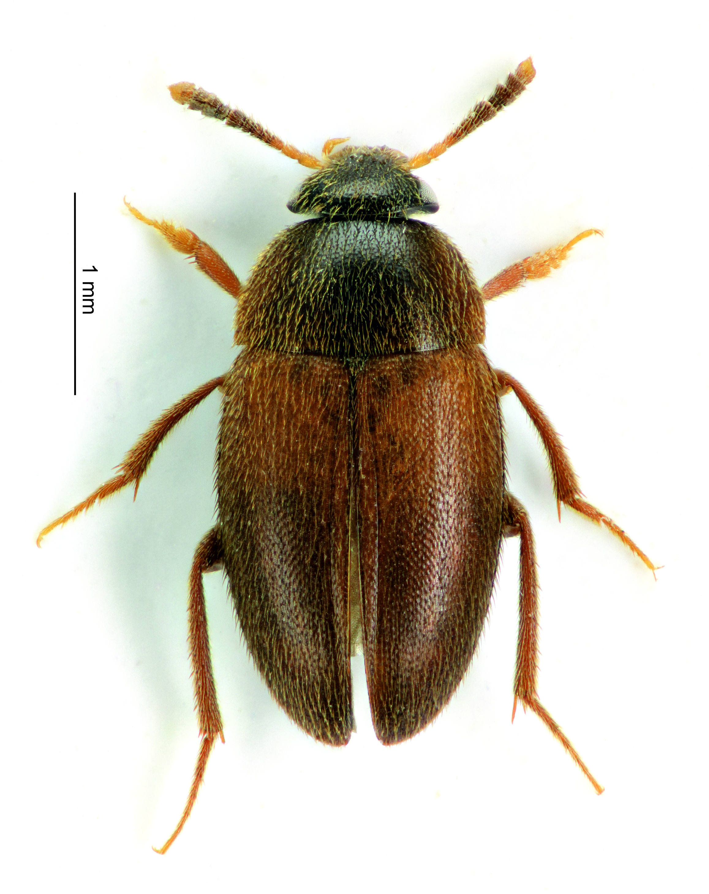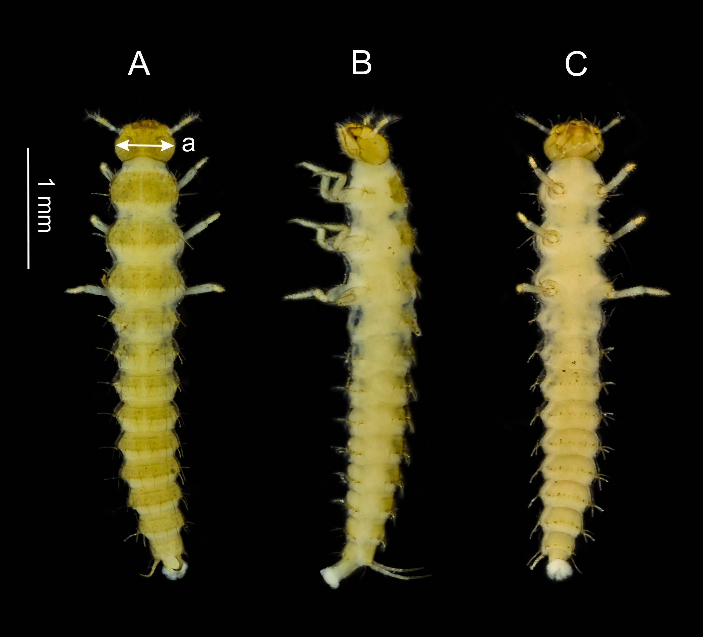

Fig.3: Dorsal (A), lateral (B) and ventral (C) side of the third larval instar of *S. watsoni*. Point where the head width was measured is shown (a).

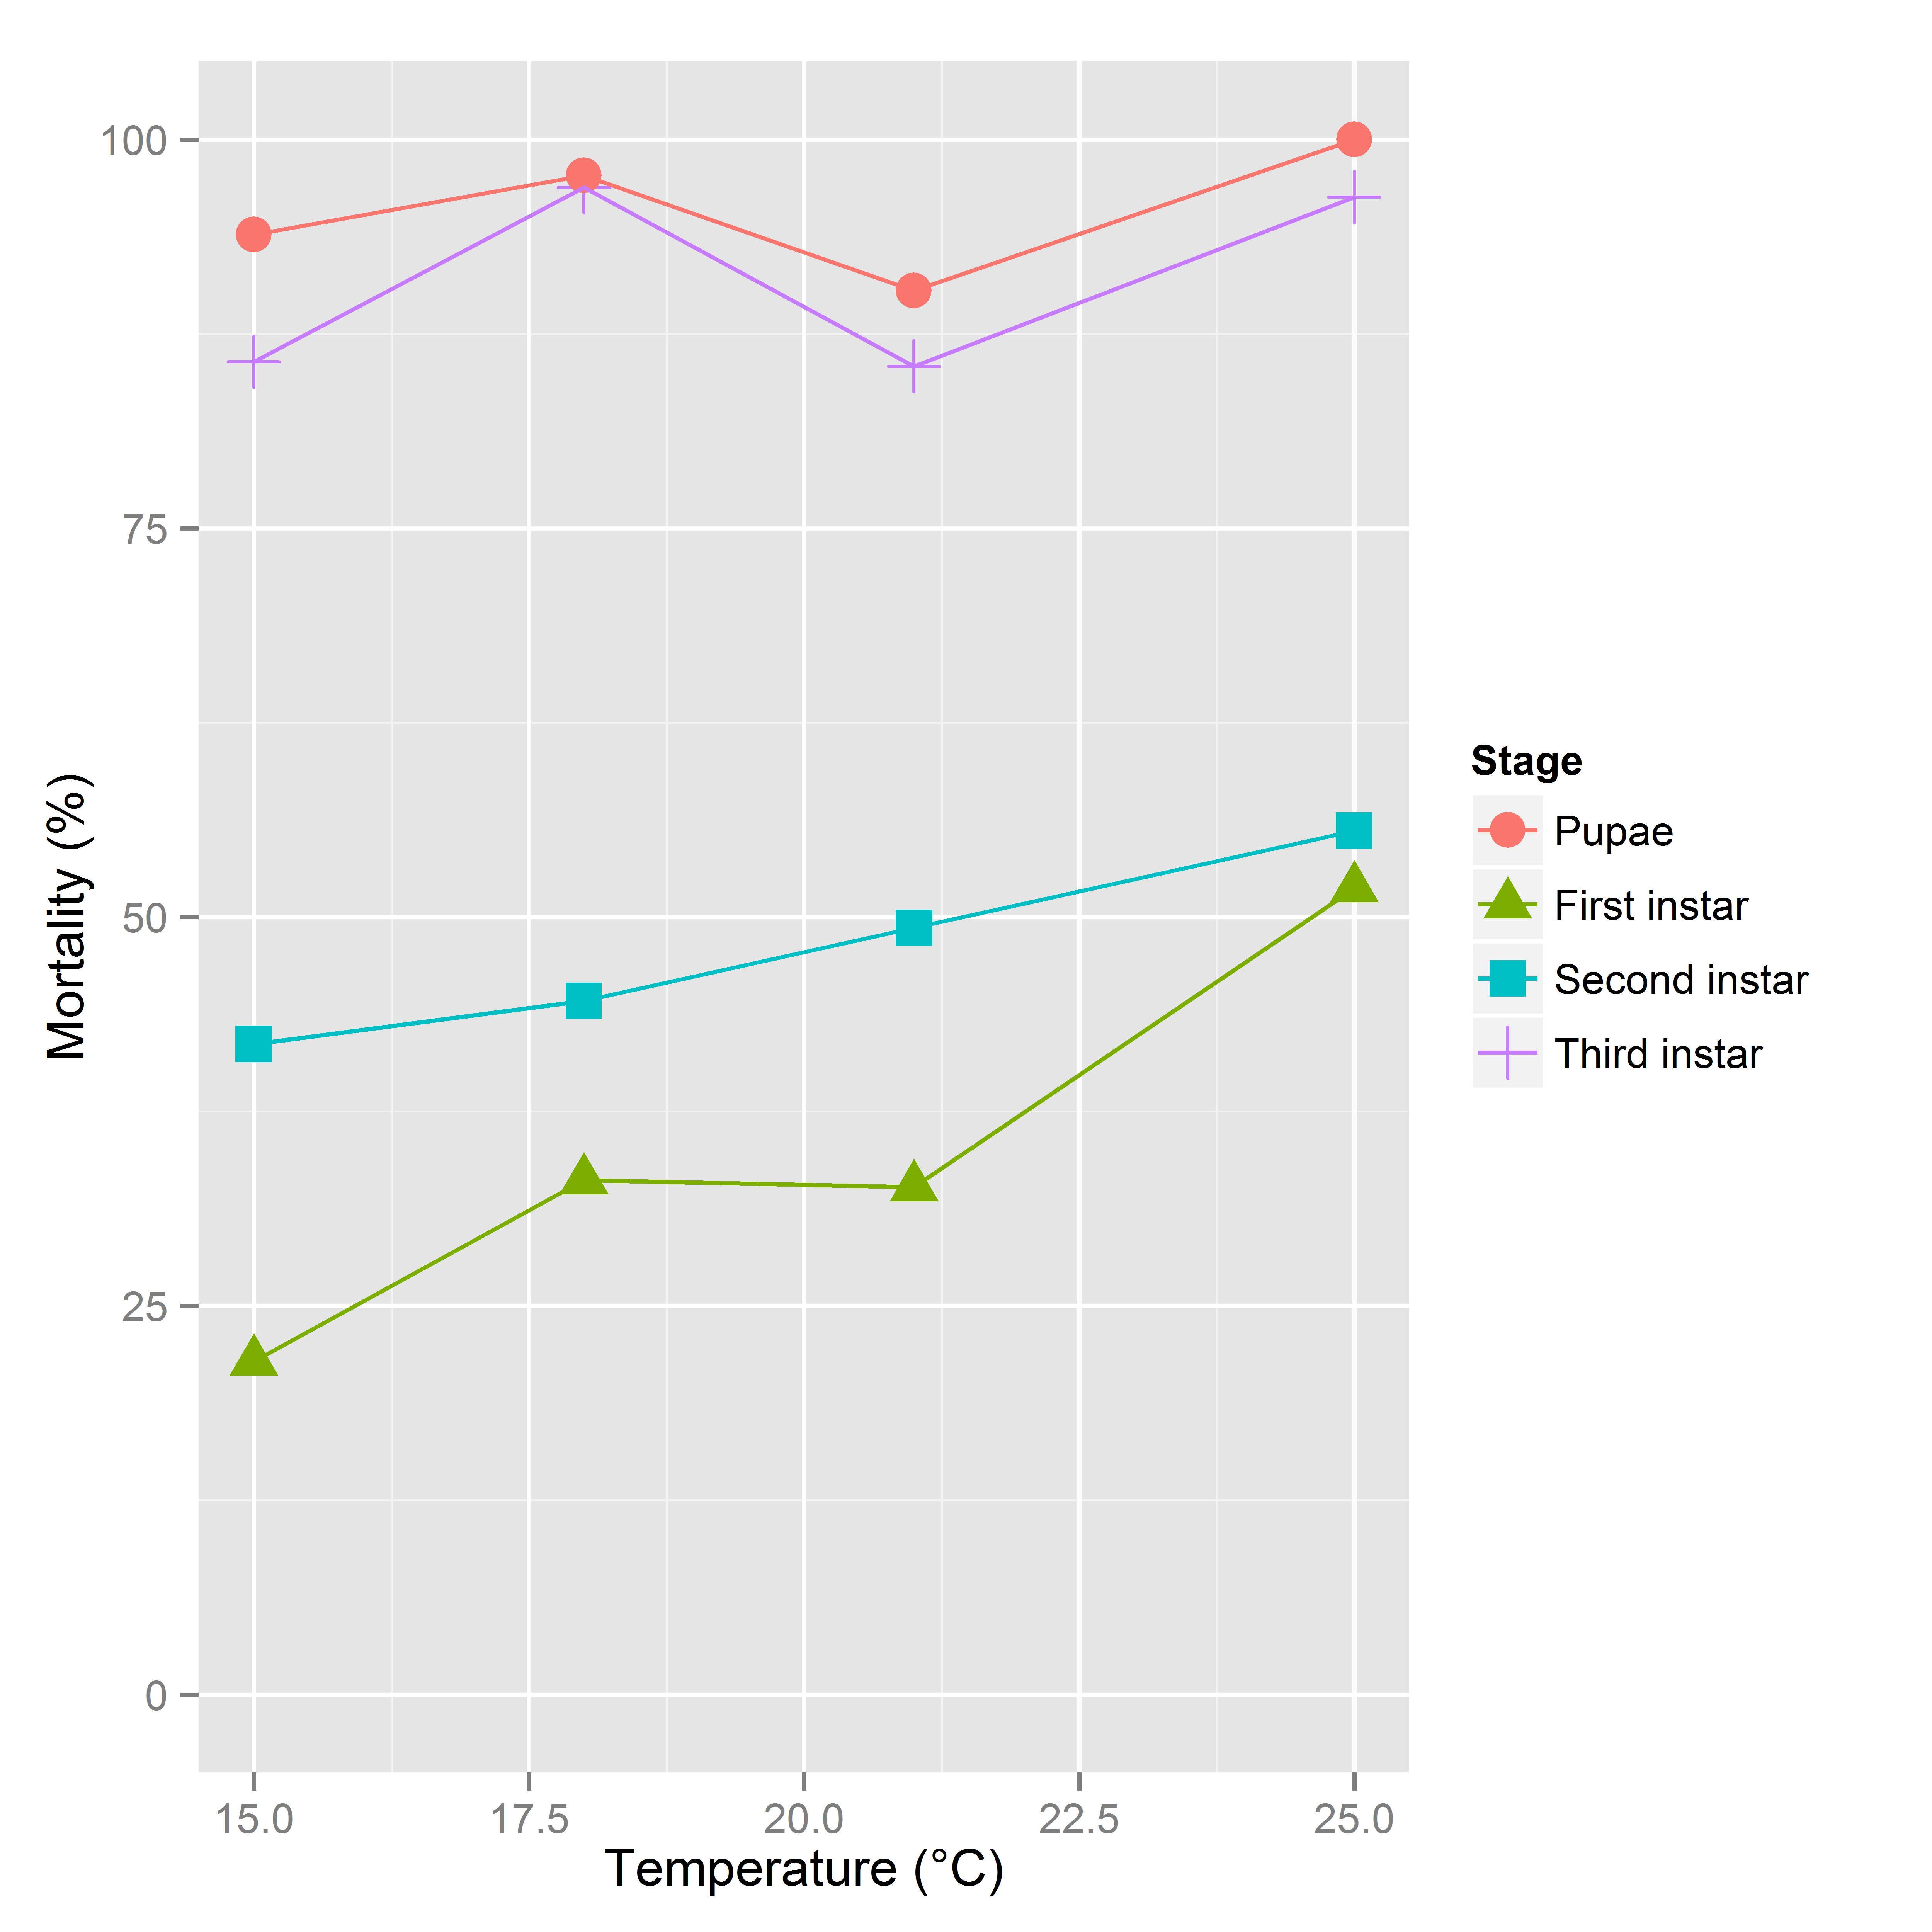

Fig. 4: Mortality rates between developmental stages of *S. watsoni*. The 28 and 12 °C treatment is not shown, because breeding did not occur.

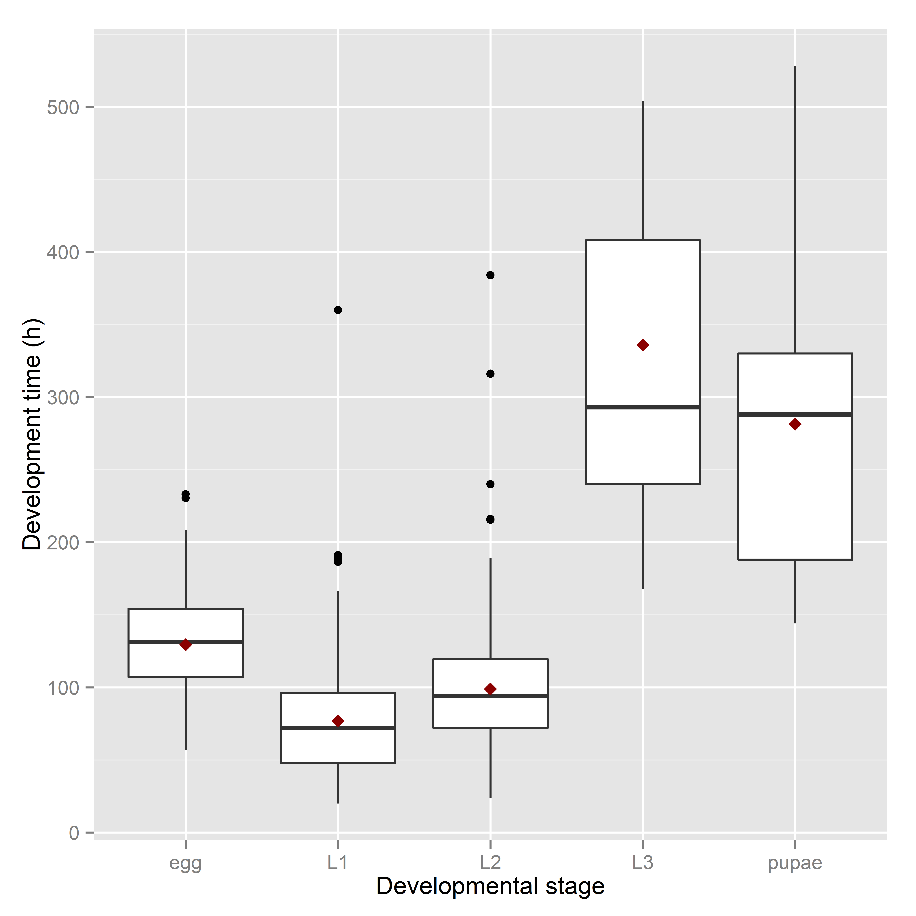

Fig. 5: Observed range of development times of *S. watsoni* over four experimental treatments (15, 18, 21, 25 °C) for each developmental stage (2012 data were excluded for egg and L1). The horizontal lines within the boxes indicate median values. The upper and lower boxes indicate the 75th and 25th percentiles, respectively. Whiskers indicate the values with the 1.5 interquartile ranges. Small, black dots are outliers. Small red dots are the mean values of development time.

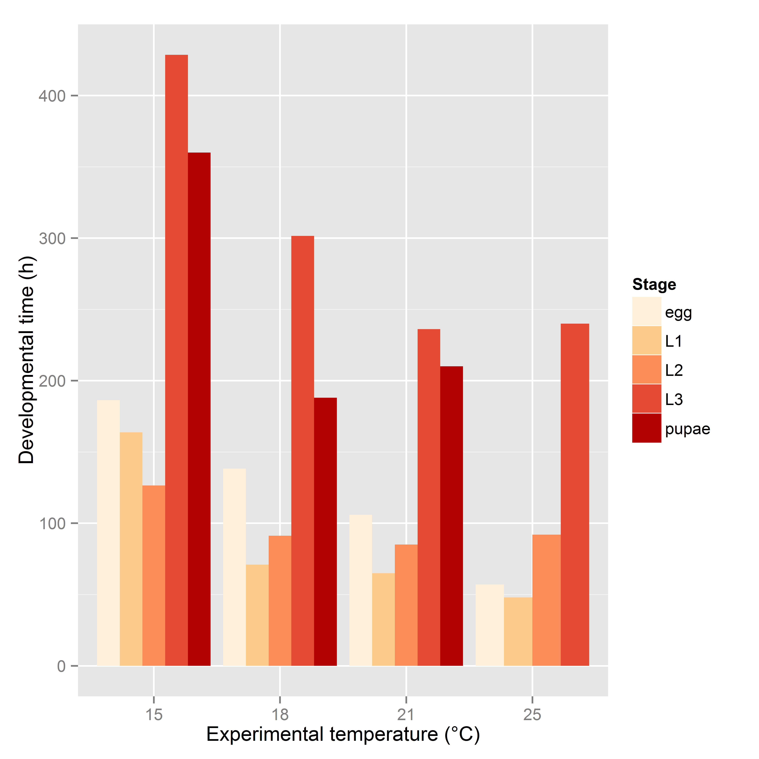

Fig. 6: Bar plot of mean development time (in hours) of all observed stages (2012 data were excluded for egg and L1) of *S. watsoni* over the whole range of experimental temperature except the 28 and 12 °C, where beetles did not breed successfully.



Fig. 7: Major axis regression for all stages of development in *S. watsoni*. Black line shows median and grey area around is standard error. DT is the time in days to reach the stage multiplied by the constant rearing temperature. 2012 data were excluded for egg and L1.

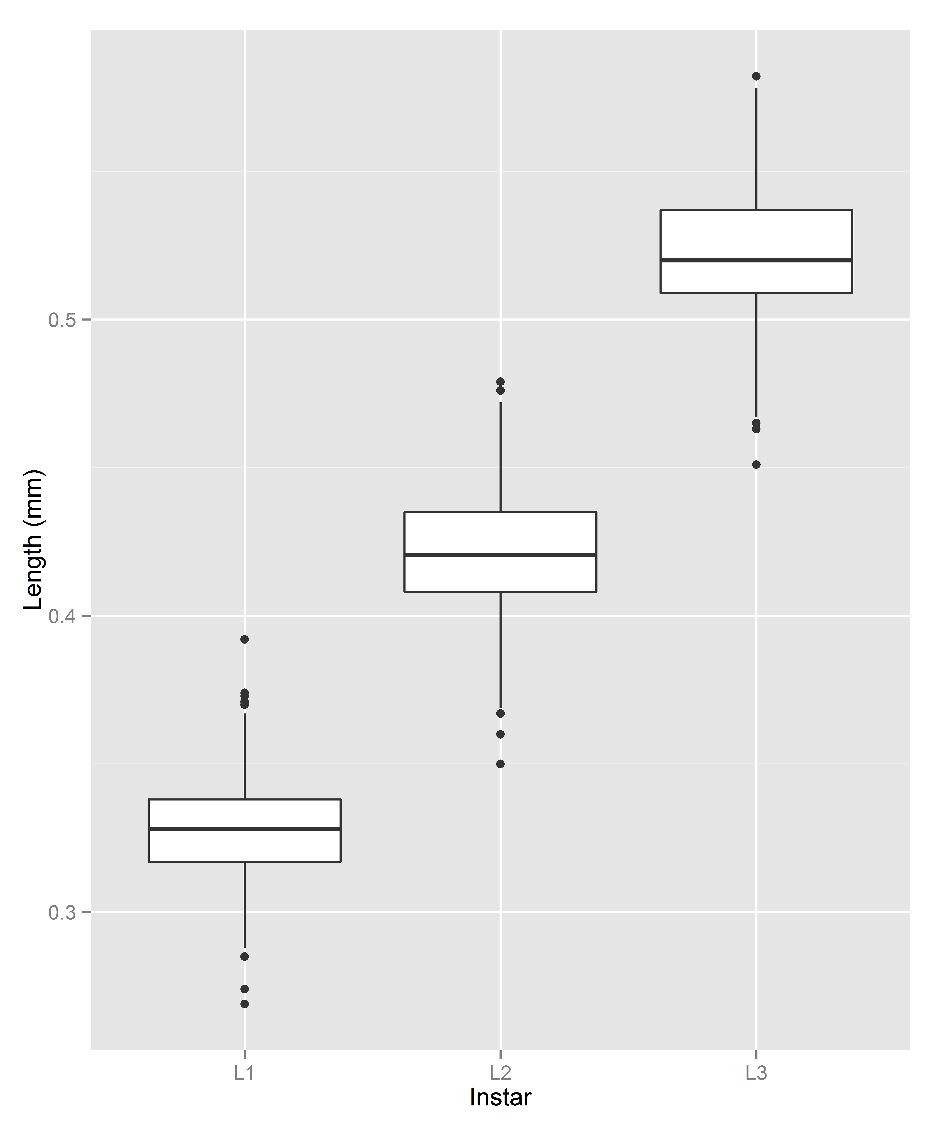

Fig. 8: Box plot graph of lengths of all three instars (L1, L2 and L3) of the *S. watsoni* larvae. The horizontal lines within the boxes indicate median values. The upper and lower boxes indicate the 75th and 25th percentiles, respectively. Whiskers indicate the values with the 1.5 interquartile ranges. Small, black dots are outliers.